

|  |  |
| --- | --- |
| **Project Name** | Integrated Common Services to Common People |
| **Prepared by** | Anushka. Daflapurkar |
| **Institution** | SMV College Of Engineering, Raichur |
| MENTOR | |

* Industrial mentor- Mr. Debdyut Hazra
* College Mentor- Prof. R.K Ashwin

|  |
| --- |
| ACKNOWLEDGEMENTS |

* Mr. Sachin Adi, who guided me throughout the process of building this project



MARKET RESEARCH

In today’s fast paced world, accessing the right healthcare from vast set of innumerable service providers is so time consuming.

Every Health service providers host their own websites ,leading to the common people to visit each and every website and then check for their Availability, Timings, Contact and Address.

This leads to more unnecessary time consumption of the users, so Integrating all the service provisions in a comprehensive manner is the solution to this gap between the user and the service provider.

TABLE OF CONTENTS

|  |  |
| --- | --- |
| CONTENTS | PAGE NUMBER |
| 1. INTRODUCTION | 4-7 |
| 2. ANALYSIS | 8-12 |
| 3. DESIGN AND IMPLEMENTATION | 13-16 |
| 4. PERFORMANCE AND TESTING | 17-26 |
| 1. CONCLUSION | 27 |

CHAPTER 1 : INTRODUCTION

* 1. PROBLEM DEFINITION
  2. AIM AND OBJECTIVE
  3. SCOPE
  4. PROJECT SPECIFICATIONS
  5. DEFINITIONS

CHAPTER 2 : ANALYSIS

2.1 SYSTEM REQUIREMENT ANALYSIS

2.2 SYSTEM FEASIBILITY

2.3 SOFTWARE INTERFACE

2.4 FRAMEWORKS DESCRIPTION

2.5 USE- CASE DIAGRAMS

CHAPTER 3 : DESIGN AND IMPLEMENTATION

3.1 DATA FLOW DIAGRAMS

3.2 DATABASE DESIGNS AND SCHEMA

3.3 CLASS DIAGRAMS

3.4 HIGH LEVEL ARCHITECTURE

CHAPTER 4 : PERFORMANCE AND TESTING

4.1 PERFORMANCE

4.2 TECHNOLOGICAL STACK USED

4.3 HOW THE COMPONENTS ARE COMMUNICATING THROUGH

EACH OTHER?

4.4 LIMITATIONS AND FUTURE WORKS

CHAPTER 5: MISCELLANEOUS

* 1. CONCLUSION
  2. SOURCES AND ACQUAINTANCES
  3. USER FEEDBACK



INTRODUCTION

* 1. PROBLEM DEFINITION

In today’s fast paced world, accessing the right healthcare from vast set of innumerable service providers is so time consuming. Every Health service providers host their own websites ,leading to the common people to visit each and every website and then check for their Availability, Timings, Contact and Address.

1.2 AIM AND OBJECTIVE

This integrated health service platform is a comprehensive web application designed to promote a seamless access to a wide range of healthcare services for the general public. The platform aims to bridge the gap between the patients and healthcare providers by providing a uniform portal where users can easily register, login, search for various health services, while service providers can register, manage their profiles, and offer their services.

By addressing fragmentation, accessibility issues, inefficiencies, data management challenges and provider difficulties in the current healthcare system, this aims to transform the healthcare experience for both patients and providers. The platform’s unified approach will lead to improved healthcare outcomes, greater convenience, and enhanced user satisfaction.

The security and privacy of user data, maintaining compliance with relevant regulations is ensured.

* 1. SCOPE

**1. User Management:**

- **Registration**: Allow users (patients) and service providers (clinics, labs, pharmacies, insurance companies, nursing services) to register on the platform.

- **Login/Logout**:- Provide secure login and logout functionality for all users.

- Profile Management: Enable users and providers to manage their profiles, including updating personal information, contact details, and service offerings.

**2. Service Discovery:**

- **Search Services**: Allow users to search for various healthcare services based on location, type of service, and availability.

- **Service Listings**: Provide detailed listings of available services, including clinic appointments, lab tests, pharmacy products, nursing services, and health insurance plans.

**3.** **Security and Privacy**:

- Implement robust security measures to protect user data, including encryption, secure authentication, and access controls.

- Ensure compliance with healthcare regulations such as HIPAA for data privacy and security.

**4.** **Scalability and Performance**:

- Design the platform to handle a large number of users and service providers, ensuring smooth performance and scalability.

- Optimize database queries and server responses for efficient data retrieval and processing.

* 1. PROJECT SPECIFICATIONS

This platform strives to facilitate best medical facility at small towns and remote area where the lack of proper guidance to proper healthcare can be improvised.

**Registration**: Secure sign-up for login for role-based access like providers and users.

**Service listings**: Detailed information with necessary fields.

**Search pharmacies**: Find nearby pharmacies.

**Request Nursing services**: Dashboard for all the nearby nursing services available.

**Health Insurance management**: Access to all the offline Health Insurance offices and related details.

**Security and Privacy**: Encrypted password to protect sensitive data.

**User Support**: Help documentations and health related articles for users to care about their health.

* 1. DEFINITIONS

1. **HTML (Hyper text markup language)**

HTML (Hyper Text Markup Language) is the most basic building block of the Web. It defines the meaning and structure of web content. Other technologies besides HTML are generally used to describe a web page's appearance/presentation (CSS) or functionality/behaviour (JavaScript).

"Hypertext" refers to links that connect web pages to one another, either within a single website or between websites. Links are a fundamental aspect of the Web. By uploading content to the Internet and linking it to pages created by other people, you become an active participant in the World Wide Web.

1. **CSS (Cascading Style Sheets)**

Cascading Style Sheets (CSS) is a stylesheet language used to describe the presentation of a document written in HTML or XML (including XML dialects such as SVG, MathML or XHTML). CSS describes how elements should be rendered on screen, on paper, in speech, or on other media. CSS (Cascading Style Sheets) is used to style and layout web pages — for example, to alter the font, color, size, and spacing of your content, split it into multiple columns, or add animations and other decorative features.

1. **JS (JavaScript)**

JavaScript is a scripting or programming language that allows you to implement complex features on web pages — every time a web page does more than just sit there and display static information for you to look at — displaying timely content updates, interactive maps, animated 2D/3D graphics, scrolling video jukeboxes, etc. — you can bet that JavaScript is probably involved. It is the third layer of the layer cake of standard web technologies, two of which are HTML and CSS.

1. **PHP (Hyper text Preprocessor)**

The term PHP is an acronym for – Hypertext Preprocessor. PHP is a server-side scripting language designed specifically for web development. It is open-source which means it is free to download and use. It is very simple to learn and use. The file extension of PHP is “.php”.

It can be integrated with many databases such as Oracle, Microsoft SQL Server, MySQL, PostgreSQL, Sybase, and Informix. It supports main protocols like HTTP Basic, HTTP Digest, IMAP, FTP, and others. The only information that the client or browser knows is the result returned after executing the PHP script on the server and not the actual PHP codes present in the PHP file. Also, PHP files can support other client-side scripting languages like CSS and JavaScript.

1. **SQL (Structured Query Language)**

SQL stands for Structured Query Language. SQL is a computer language used to interact with relational database systems. SQL is a tool for organizing, managing, and retrieving archived data from a computer database.

When data needs to be retrieved from a database, SQL is used to make the request. The DBMS processes the SQL query retrieves the requested data and returns it to us. Rather, SQL statements describe how a collection of data should be organized or what data should be extracted or added to the database.

In common usage, SQL encompasses DDL and DML commands for CREATE, UPDATE, MODIFY, or other operations on database structure.



SYSTEM ANALYSIS

2.1 SYSTEM REQUIREMENT ANALYSIS

After analyzing the requirement of the task to be performed, the next step is to analyze the problem and understand its context. The first activity in the phase is studying the existing system and other is to understand the requirement and domain of the new system.Both the activity are equally important, but the first activity serves as a basis of giving the functional specifications and then successful designs of the proposed system. Understanding the properties and requirement of a new system is more difficult and require creative thinking and understanding of existing running system is also difficult, improper understanding of present system can lead diversion from solution.

2.2 SYSTEM AND TECHNICAL FEASIBILITY

Since, whenever a new system is created, we have to check all the aspects our manner involve in creation of system. A study of resource availability that may affect the availability to achieve an acceptable system. This evolution determines whether the technology needed for the proposed system is available or not. This is concerned with specifying equipment and software will successfully satisfy the user requirement.

FRONT END SELECTION

An important issue for the development of a project is the selection of a suitable front-end and back-end.When I had decided to build this project, I went through an extensive study to determine the most suitable platform that will suit the need of the Industry and the need of development of this project.

The focus was on enhancing the UI/UX experience to all the users interacting with this platform.

Other than that scalability, robustness, flexibility of the platform were considered

FACTORS CONSIDERED FOR BACKEND DEVELOPMENT

* Multiple user support
* Operating system compatible
* Effective data retrieval
* Effective data handling
* Easy to implement with the front end
* Stored procedure

2.3 SOFTWARE INTERFACE

HOME PAGE

**Navigation Bar** : Links to Home, About, Services,Why Us, Contact Us sections.

**Home section** : Contains the links to Register/Login for Service providers as well as users(the consumers/patients).

**About us section**: Contains the motivation to solve the problem statement and the information about the solution derived by building this project.

**Services section**: Contains a list of all the services the service providers are allowed to post and for the users can avail the data.

**Why Us section** : This section consists of relying the users to use our platform by assuring them quality healthcare services.

**Contact Us section**: Contains the fields for the users/service providers to directly contact the admin to resolve the issues they are facing.

USER REGISTRATION/LOGIN PAGE :

**Navigation Bar** : Contains a navigation bar to hold the links for Home page, About Us and Contact Us section.

**User Login button** : Opens a modal asking for data fields to be filled by the user including their respective email id, password for login.

If the user is not registered, upon clicking on Signup, it opens a modal window again asking for their respective email id and password.There is a checkbox to be ticked saying that the users are agreeing to the terms and conditions of the platform.

**User Dashboard**:

Contains health related articles for the users to browse and read about the trending health issues others are facing and take the motivation to look after their health more properly.

SERVICE PROVIDER REGISTRATION/LOGIN PAGE :

**Navigation Bar** : Contains a navigation bar to hold the links for Home page, About Us and Contact Us section.

**Service provider Login button** : Opens a modal asking for data fields to be filled by the service provider including their respective email id, password for login.

If the service provider is not registered, upon clicking on Signup, it opens a modal window asking for their respective email id, select their service from a dropdown menu, area, contact number, Address, Password.There is a checkbox to be ticked saying that the Service providers are agreeing to the terms and conditions of the platform.

**Service providers dashboard**:

Contains health related articles for the users to browse and read about the trending health issues others are facing and take the motivation to look after their health more properly.

2.4 FRAMEWORK DESCRIPTIONS

Bootstrap is a free front-end framework for faster and easier web development. Bootstrap includes HTML and CSS based design templates for typography, forms, buttons, tables, navigation, modals, image carousels and many other, as well as optional JavaScript plugins. Bootstrap also gives you the ability to easily create responsive designs. Bootstrap was developed by Mark Otto and Jacob Thornton at Twitter, and released as an open source product in August 2011 on GitHub.

**Advantages of Bootstrap**:

* **Easy to use**: Anybody with just basic knowledge of HTML and CSS can start using Bootstrap
* **Responsive features**: Bootstrap's responsive CSS adjusts to phones, tablets, and desktops
* **Mobile-first approach**: In Bootstrap 3, mobile-first styles are part of the core framework
* **Browser compatibility**: Bootstrap is compatible with all modern browsers (Chrome, Firefox, Internet Explorer, Edge, Safari, and Opera).

2.5 USE CASE DIAGRAMS

2.5.1 OVERALL USE CASE DIAGRAM

Register

Login

Logout

Data results

User

Admin

Service Provider

2.5.2 SERVICE PROVIDER CASE DIAGRAM:

Register

Login

Logout

Data upload for service provision

Service Provider

2.5.3 USER CASE DIAGRAM:

Register

Login

Logout

Data retrieval

User



DESIGN AND IMPLEMENTATION

**DATA FLOW DIAGRAM**

A data flow diagram (DFD) maps out the flow of information for any process or system. It uses defined symbols like rectangles, circles and arrows, plus short text labels, to show data inputs, outputs, storage points and the routes between each destination.

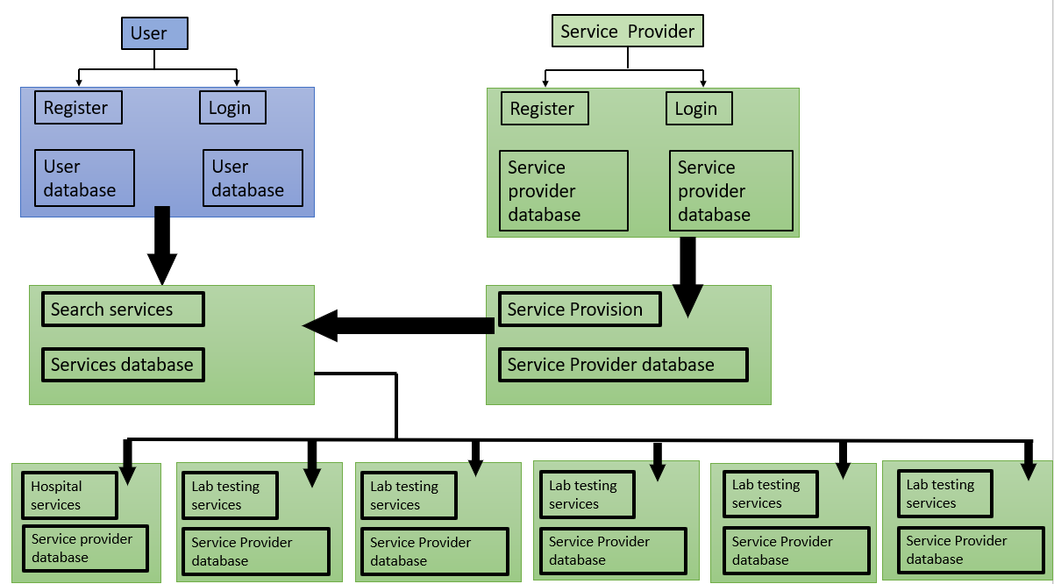

**CLASS DIAGRAMS**

Class diagrams are a type of UML (Unified Modeling Language) diagram used in software engineering to visually represent the structure and relationships of classes in a system. UML is a standardized modeling language that helps in designing and documenting software systems. They are an integral part of the software development process, helping in both the design and documentation phases.

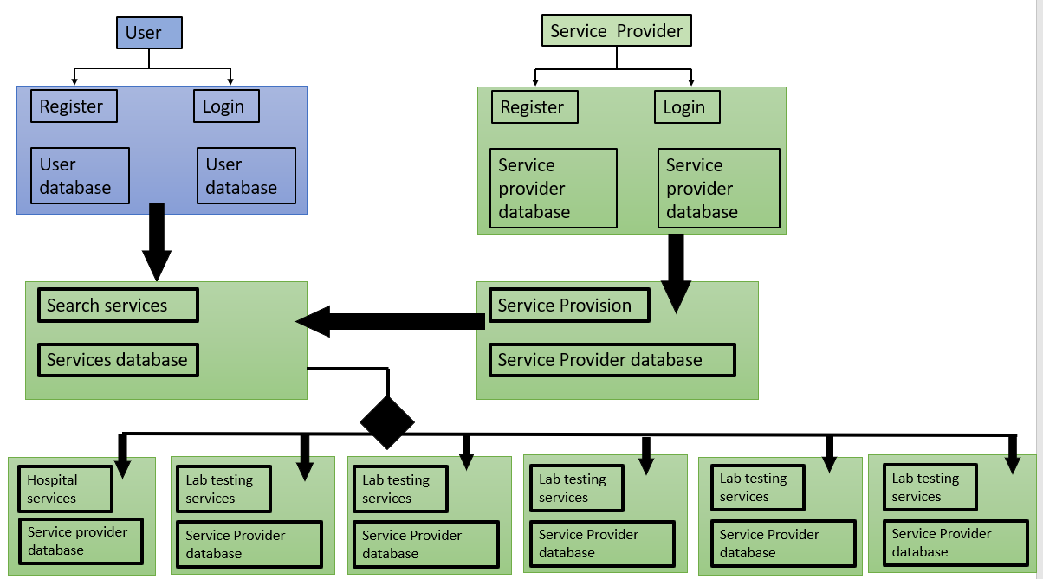

**DATABASE DESIGNS AND SCHEMA**

The database design ensures efficient data management and retrieval, supporting the core functionalities of this platform of Integrated health services.

1. USERS TABLE

CREATE TABLE USERS(

USERID INT PRIMARY KEY AUTO INCREMENT,

NAME VARCHAR(100) NOT NULL,

EMAILID VARCHAR(100) NOT NULL,

PASSWORD VARCHAR(100) NOT NULL

);

1. SERVICE PROVIDERS TABLE

CREATE TABLE SERVICEPROVIDER(

PROVIDERID INT PRIMARY KEY AUTO INCREMENT,

EMAILID VARCHAR(100) NOT NULL,

PASSWORD VARCHAR(100) NOT NULL,

ADDRESS VARCHAR(100) NOT NULL

);

**HIGH LEVEL ARCHITECTURE**

A High-Level Architecture (HLA) is a family of related standards that together describe a unified approach and common architecture to constructing interoperable simulation systems. It contains major functional elements, interfaces, and design rules, pertaining to all DoD simulation applications.

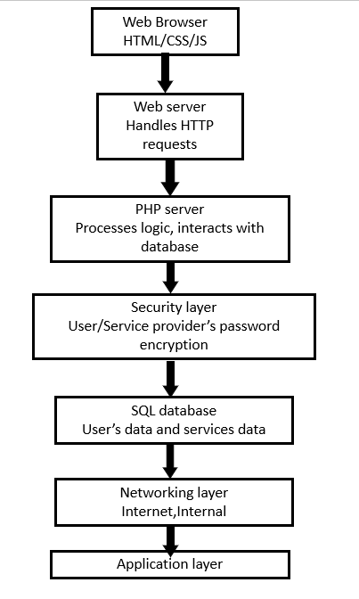



**PERFORMANCE AND TESTING**

**4.1 PERFORMANCE TESTING**

The application meets all the requirements and performs well under decent expected load conditions.

The application also meets the responsiveness i.e it is successfully tested on different screen sizes and is deliverable.

**4.2 TECHNOLOGICAL STACK USED**

1. **HTML**

Hypertext Markup Language (HTML) is the standard markup language for documents designed to be displayed in a web browser. It defines the content and structure of web content. It is often assisted by technologies such as Cascading Style Sheets (CSS) and scripting languages such as JavaScript.

HTML elements are the building blocks of HTML pages. With HTML constructs, images and other objects such as interactive forms may be embedded into the rendered page. HTML provides a means to create structured documents by denoting structural semantics for text such as headings, paragraphs, lists, links, quotes, and other items. HTML elements are delineated by tags, written using angle brackets. Tags such as <img> and <input> directly introduce content into the page. Other tags such as <p> and </p> surround and provide information about document text and may include sub-element tags. Browsers do not display the HTML tags but use them to interpret the content of the page.

2.**CSS**

Cascading Style Sheets (CSS) is a style sheet language used for specifying the presentation and styling of a document written in a markup language such as HTML or XML (including XML dialects such as SVG, MathML or XHTML).[1] CSS is a cornerstone technology of the World Wide Web, alongside HTML and JavaScript.[2]

CSS is designed to enable the separation of content and presentation, including layout, colors, and fonts.[3] This separation can improve content accessibility;[further explanation needed] provide more flexibility and control in the specification of presentation characteristics; enable multiple web pages to share formatting by specifying the relevant CSS in a separate .css file, which reduces complexity and repetition in the structural content; and enable the .css file to be cached to improve the page load speed between the pages that share the file and its formatting.

3. **JAVASCRIPT**

JavaScript is a scripting or programming language that allows you to implement complex features on web pages — every time a web page does more than just sit there and display static information for you to look at — displaying timely content updates, interactive maps, animated 2D/3D graphics, scrolling video jukeboxes, etc. — you can bet that JavaScript is probably involved. It is the third layer of the layer cake of standard web technologies, two of which (HTML and CSS).

4. **PHP**

The term PHP is an acronym for – Hypertext Preprocessor. PHP is a server-side scripting language designed specifically for web development. It is open-source which means it is free to download and use. It is very simple to learn and use. The file extension of PHP is “.php”.

PHP was introduced by Rasmus Lerdorf in the first version and participated in the later versions. It is an interpreted language and it does not require a compiler.

PHP is primarily used for server-side web development. It enables the creation of dynamic web pages by embedding PHP code within HTML.

PHP can perform various tasks, including handling form data, generating dynamic page content, managing databases, and interacting with servers.

5.**SQL**

Structured Query Language (SQL) is a specialized programming language for managing relational database data. It allows users to store, manipulate, and retrieve data efficiently in databases like MySQL, SQL Server, Oracle, and more.

SQL stands for Structured Query Language. SQL is a computer language used to interact with relational database systems. SQL is a tool for organizing, managing, and retrieving archived data from a computer database.

When data needs to be retrieved from a database, SQL is used to make the request. The DBMS processes the SQL query retrieves the requested data and returns it to us. Rather, SQL statements describe how a collection of data should be organized or what data should be extracted or added to the database.

4.3 HOW THE COMPONENTS ARE COMMUNICATING THROUGH EACH

OTHER?

**HOMEPAGE**

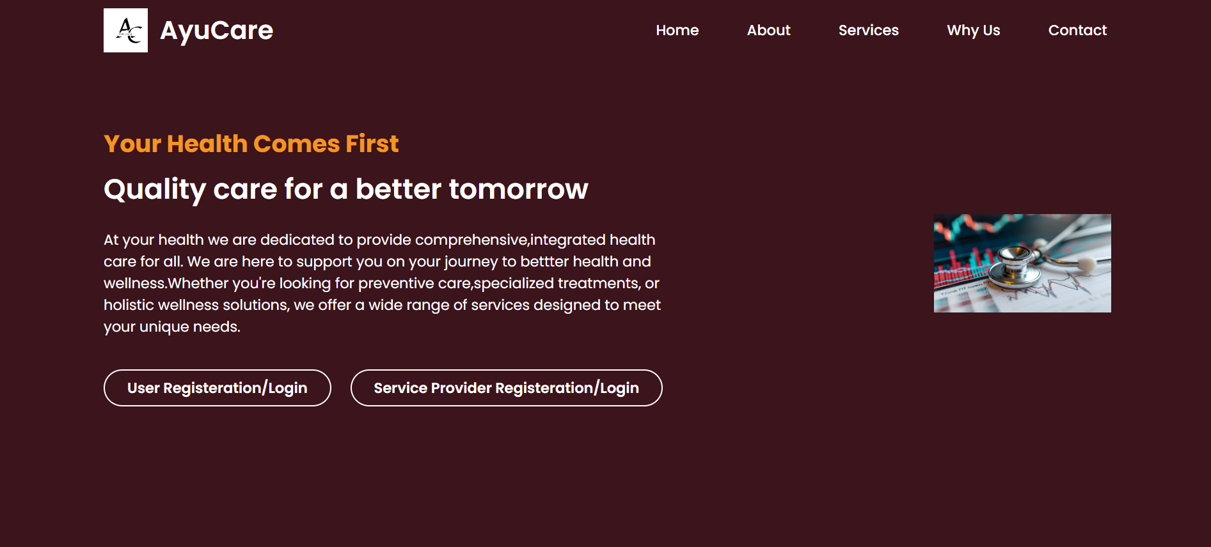

The Homepage consists of all the main contents of this project.

It consists of all the links to different sections within the webpage in its navigation bar. This includes Home, About, Services, Why Us, Contact section.

**ABOUT** : Upon clicking on About Us section, this shows up

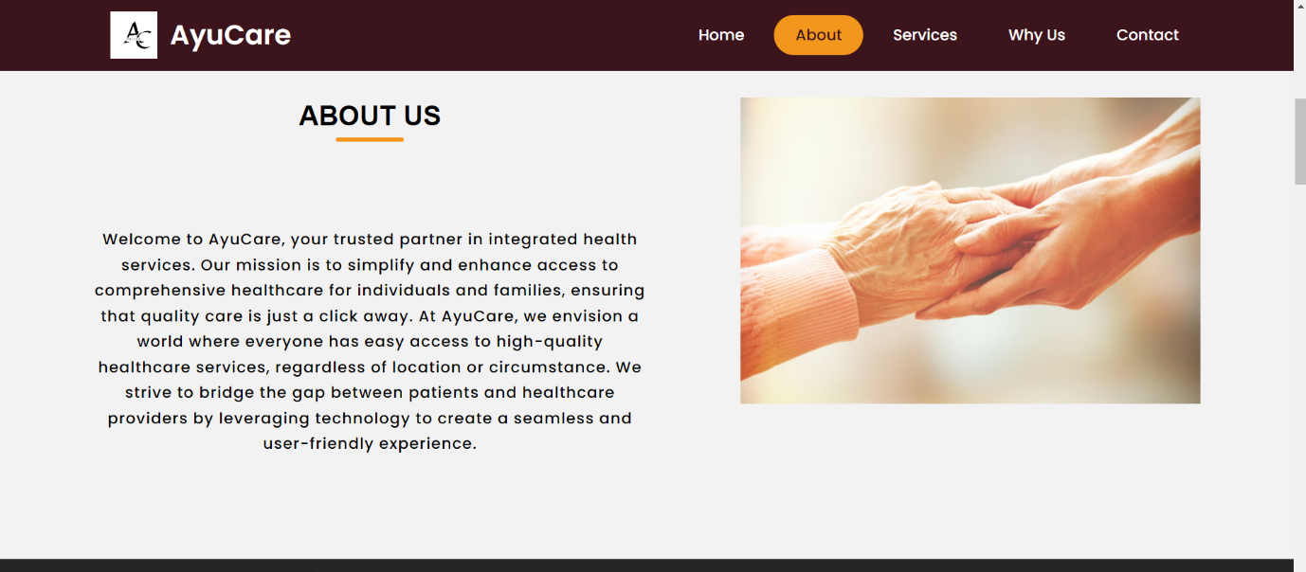

**SERVICES SECTION**: Upon clicking on Services section, this interface is met.

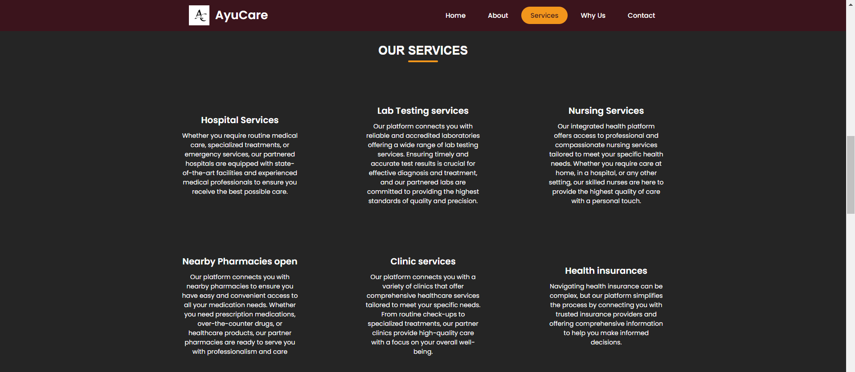

**WHY US SECTION**: Upon clicking on Why Us, this shows up

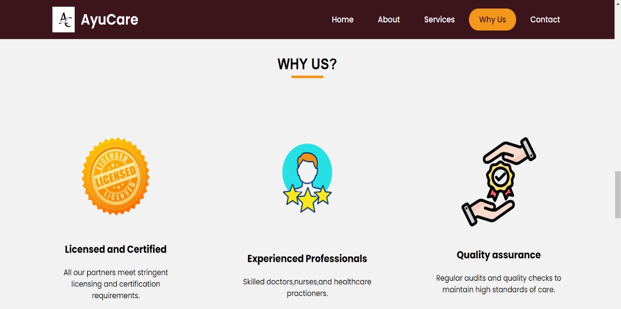

**CONTACT SECTION** : Upon clicking on Contact section, this shows up

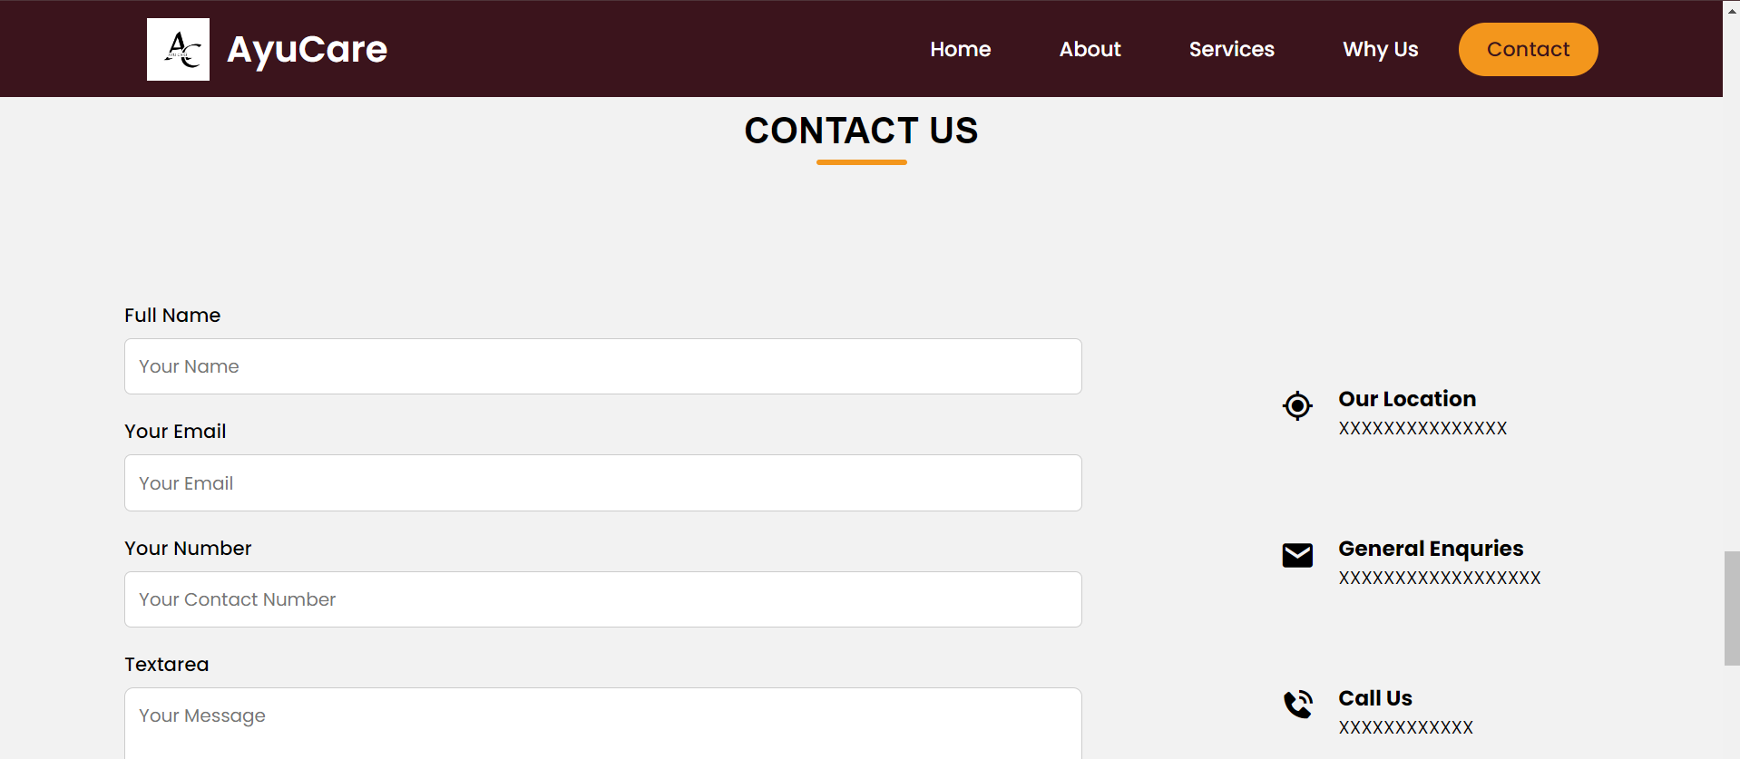

**USER REGISTRATION/LOGIN** : Upon clicking on User registration , the website is directed to a different webpage linked with user dashboard consisting few health related articles as well as the user login button in the right most corner.

If the user is already registered, the login page is displayed. If the user is not registered it asks for Signup.

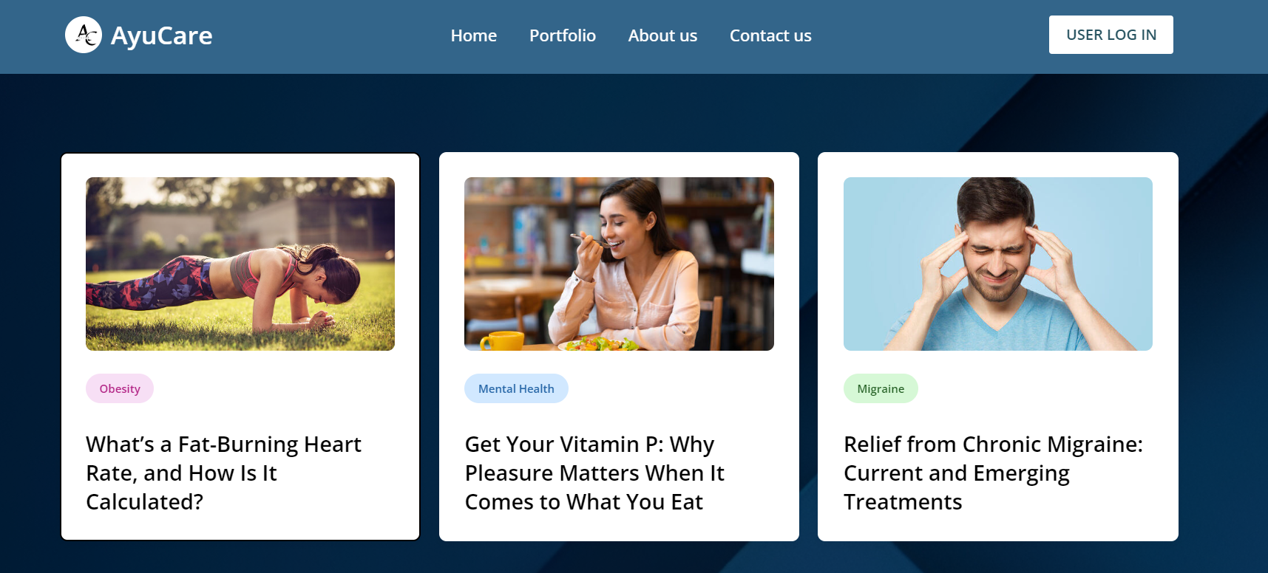

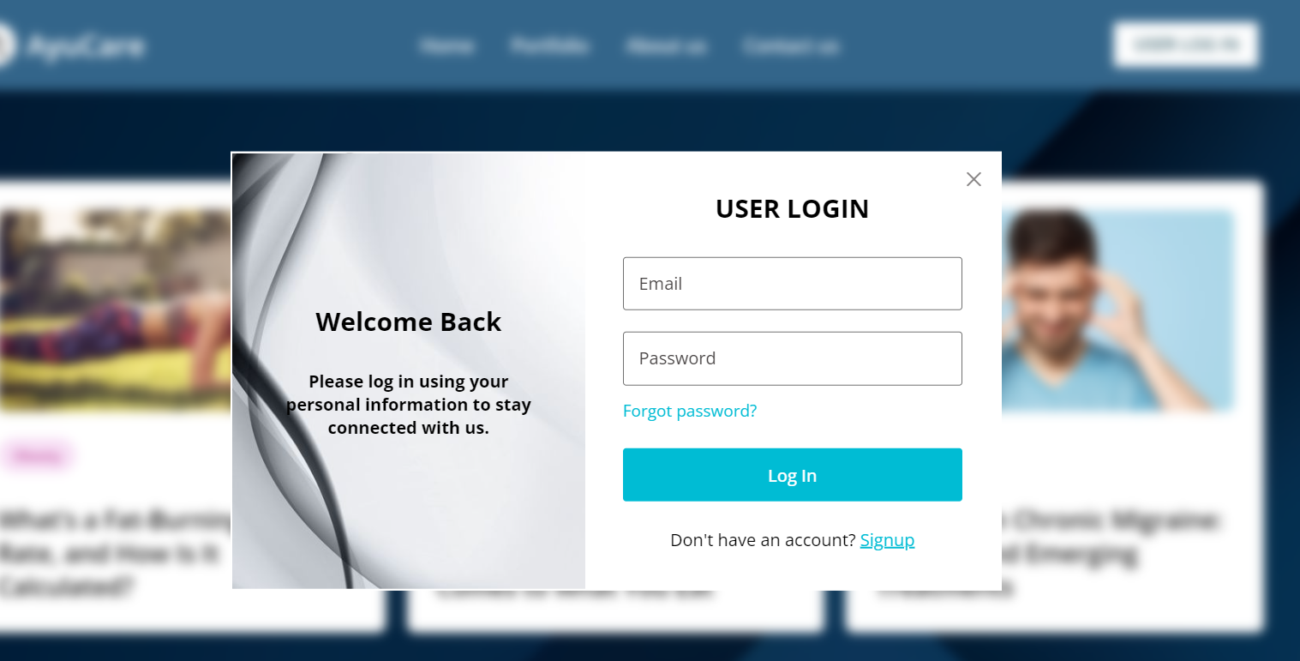

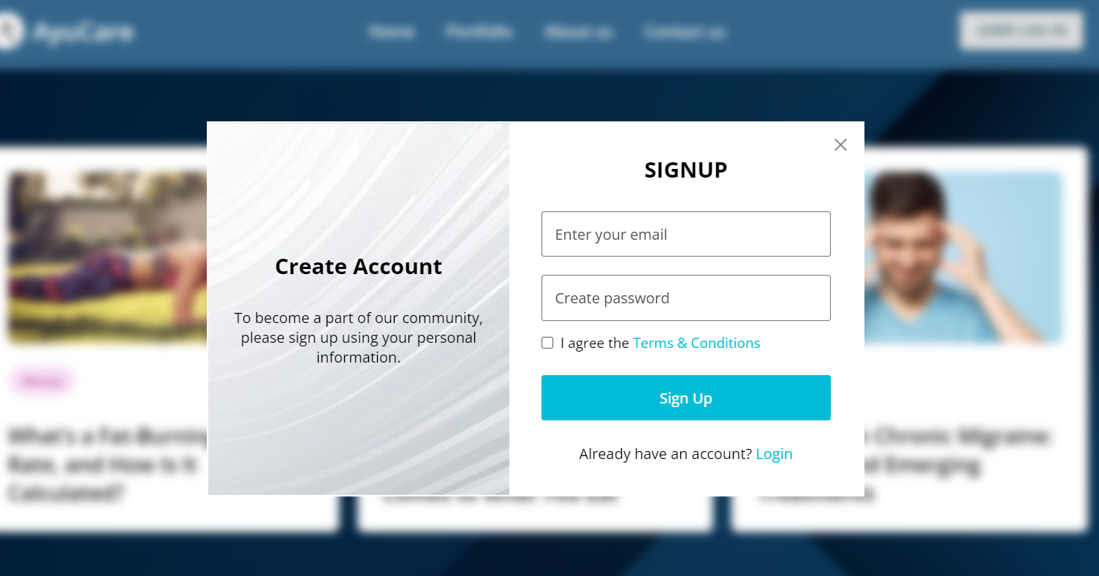

**SERVICE PROVIDER LOGIN/ REGISTRATION:**

Upon clicking on Service provider registration , the website is directed to a different webpage linked with service provider dashboard consisting few health related articles as well as the service provider login button in the right most corner.

If the service provider is already registered, the login page is displayed. If the user is not registered it asks for Signup.

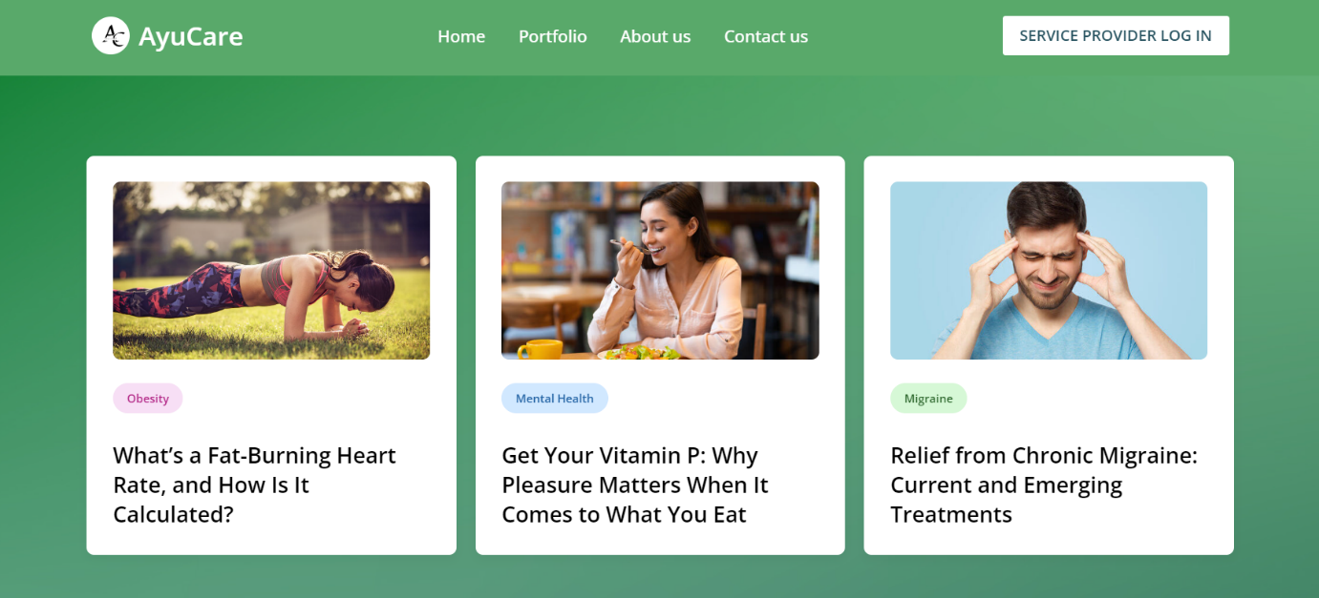

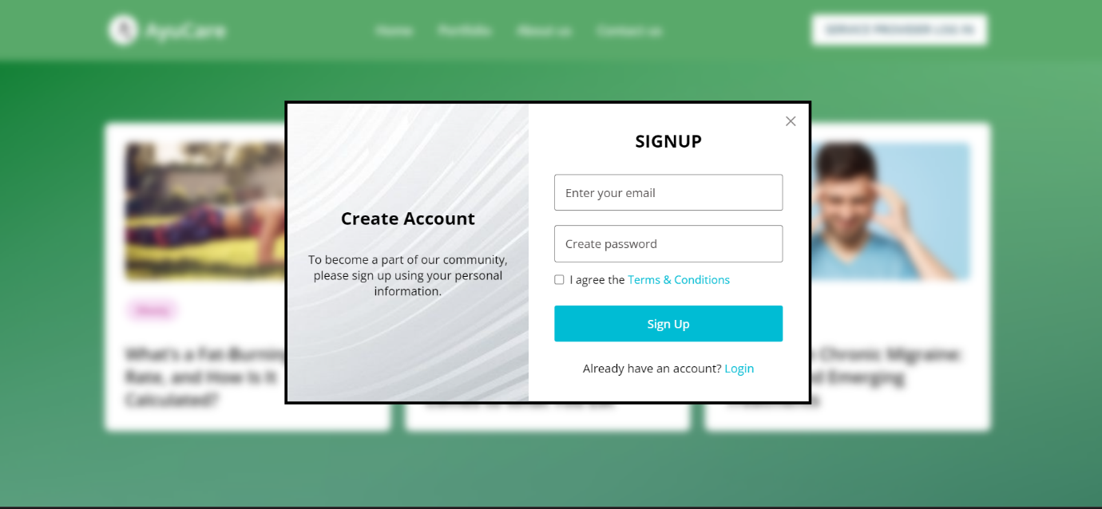

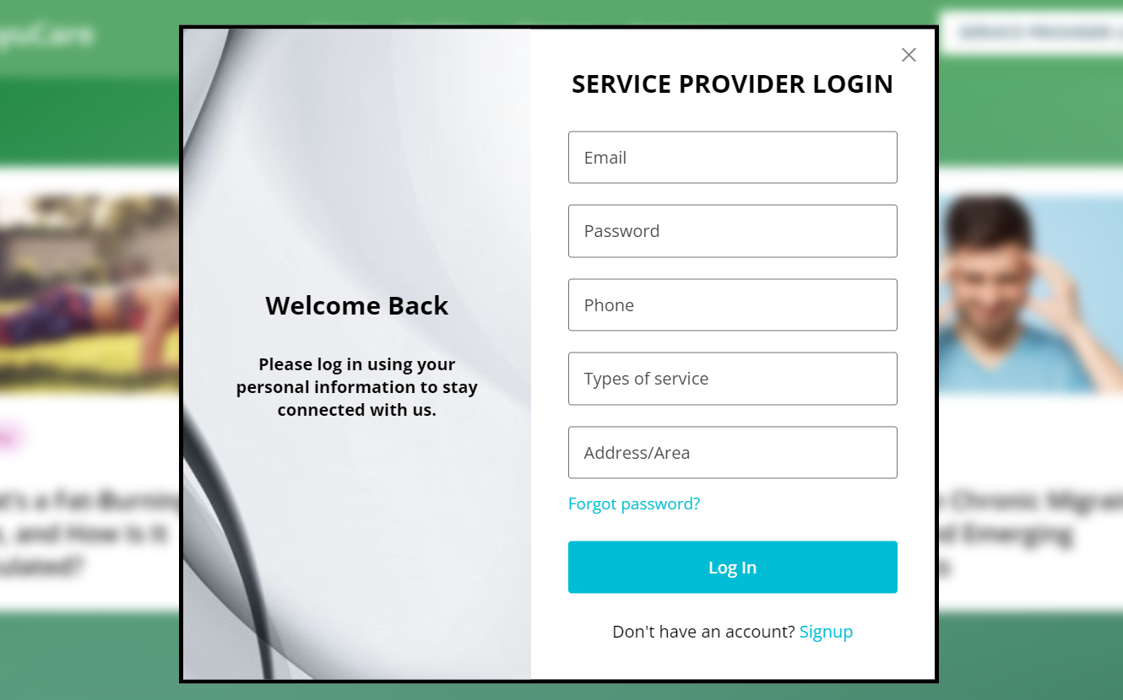

4.4.1 LIMITATIONS

**1. Scalability Constraints:**

- The current implementation may face performance issues with a significantly increased number of users and data volume, especially without adequate load balancing and server resources.

**2. Dependence on Internet Connectivity:**

- Users and providers need a stable internet connection to access the platform, which may be a limitation in areas with poor connectivity.

**3. Data Security and Privacy Concerns:**

- While security measures are implemented, there is always a risk of data breaches and cyber attacks. Ensuring compliance with privacy regulations (e.g., HIPAA) requires continuous monitoring and updates.

**4. Regulatory Compliance:**

- Keeping up with and ensuring compliance with various local, national, and international healthcare regulations is an ongoing challenge.

4.4.2 FUTURE WORKS

**1. Enhanced Scalability:**

- Implement advanced load balancing, auto-scaling, and distributed database systems to handle increased user load and data volume seamlessly.

**2. Telemedicine Integration:**

- Add telemedicine features, including video consultations, remote monitoring, and secure messaging, to expand the range of healthcare services offered.

**3. Artificial Intelligence and Machine Learning:**

- Incorporate AI/ML for personalized health recommendations, predictive diagnostics, and automated customer support through chatbots.

**4. Blockchain for Data Security:**

- Explore the use of blockchain technology for enhanced data security, immutability, and transparent health record management.

**5. IoT Integration:**

- Integrate Internet of Things (IoT) devices for real-time health monitoring, enabling remote patient monitoring and proactive health management.

**6. Expanded Insurance Services:**

- Collaborate with more insurance providers to offer a wider range of insurance plans and streamline the claims process with automated verification.

**7. Multilingual Support:**

- Implement multilingual support to cater to users from different linguistic backgrounds, enhancing accessibility and user experience.



**MISCELLANEOUS**

**CONCLUSION**

The Integrated Health Services Platform revolutionizes healthcare access by providing a unified portal for users to connect with clinics, labs, pharmacies, nursing services, and health insurers. Developed using HTML, CSS, JavaScript, PHP, and SQL, it ensures ease of use, comprehensive service integration, and efficient data management. The platform enhances user convenience and provider efficiency, fostering a more connected healthcare ecosystem. Future enhancements, including mobile apps and AI integration, promise further improvements. Despite challenges like data security and system integration, the project successfully demonstrates technology's potential to transform healthcare delivery.

**SOURCES AND ACQUAINTANCES**

Healthline : https://www.healthline.com/

Wikipedia : https://www.wikipedia.org/

Bootstrap : https://getbootstrap.com/

MDN : <https://developer.mozilla.org/en-US/>

**USER FEEDBACK SECTION**

The project contains a Contact Us section through which they can also give their respective feedbacks into the portal.

This section is still under intense development.